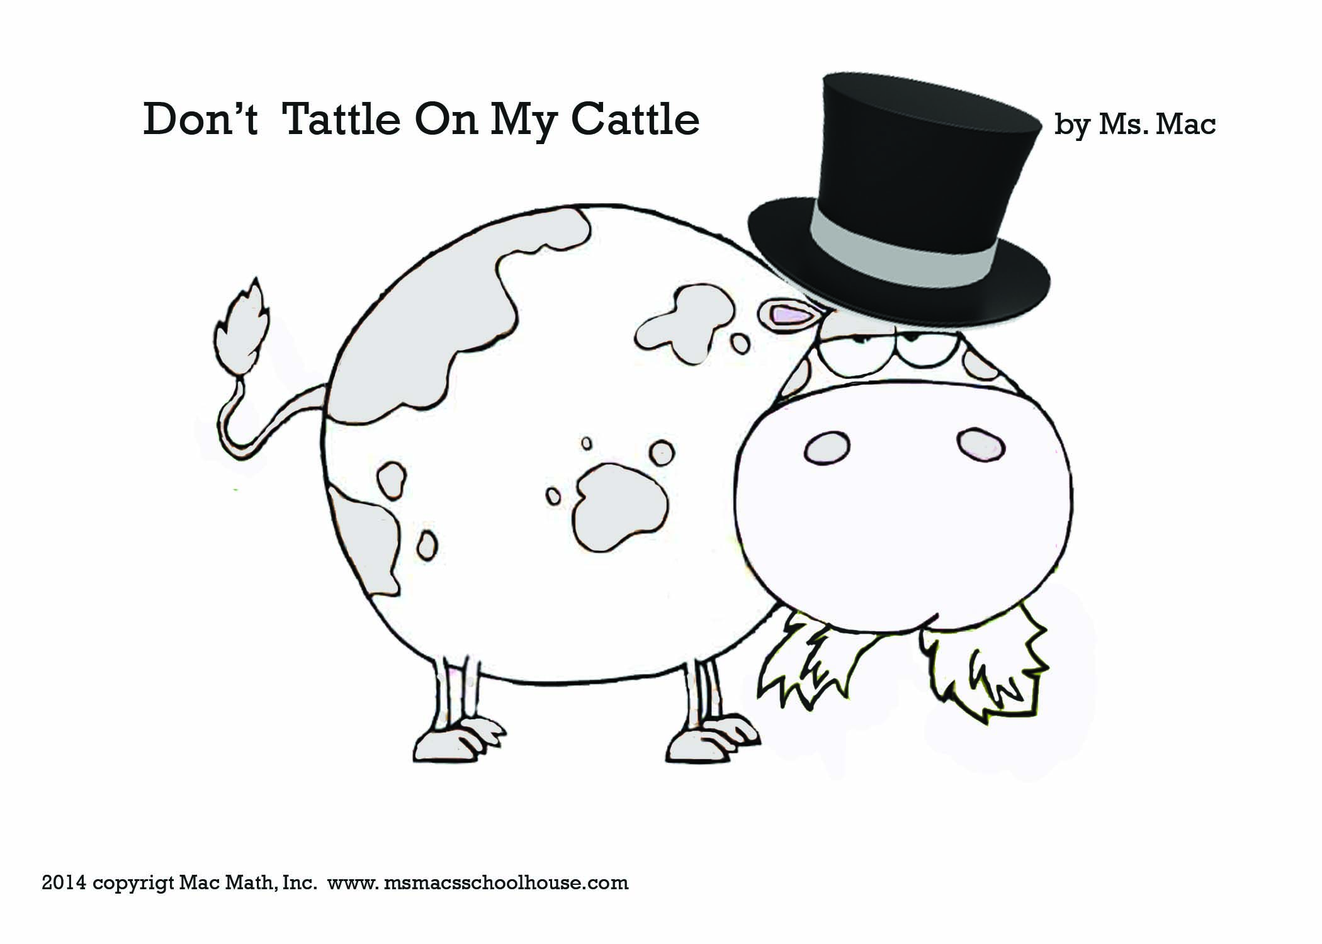
Rhyming Words:

cattle crunch blue romp slurp sleep
tattle munch two stomp burp beep
Seattle moo
rattle

