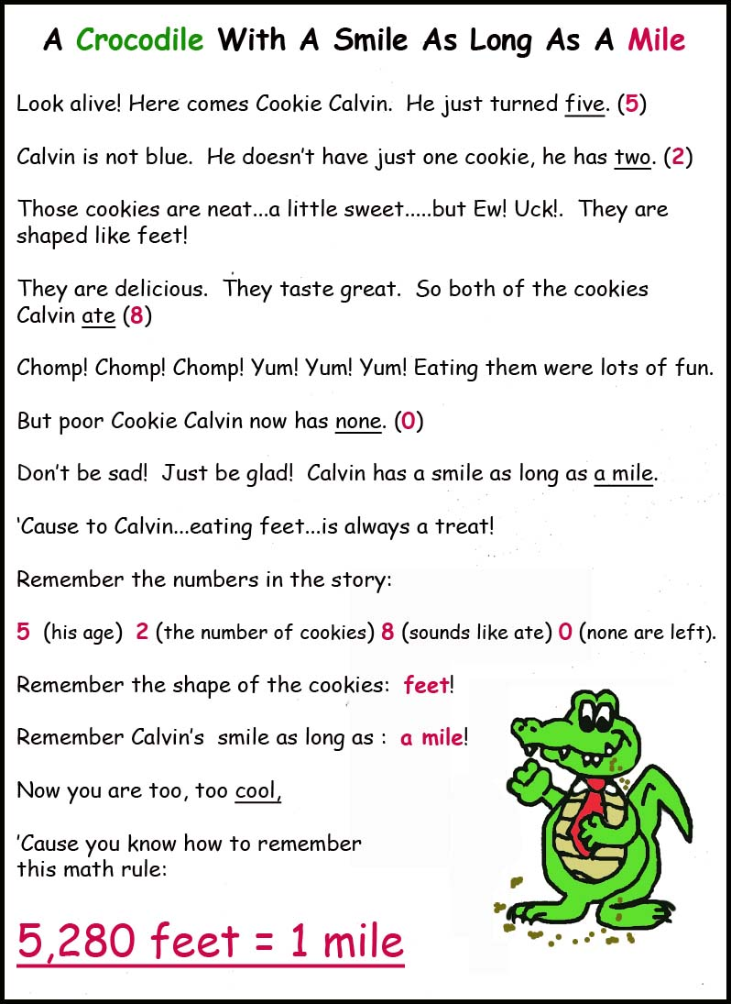
2014 Copyright Ms. Mac Schoolhouse www.msmac@wcc.net www.msmacsschoolhouse.com

